
2005 USATF-Montana
Track & Field State Championships

Junior Olympic • Open • Masters
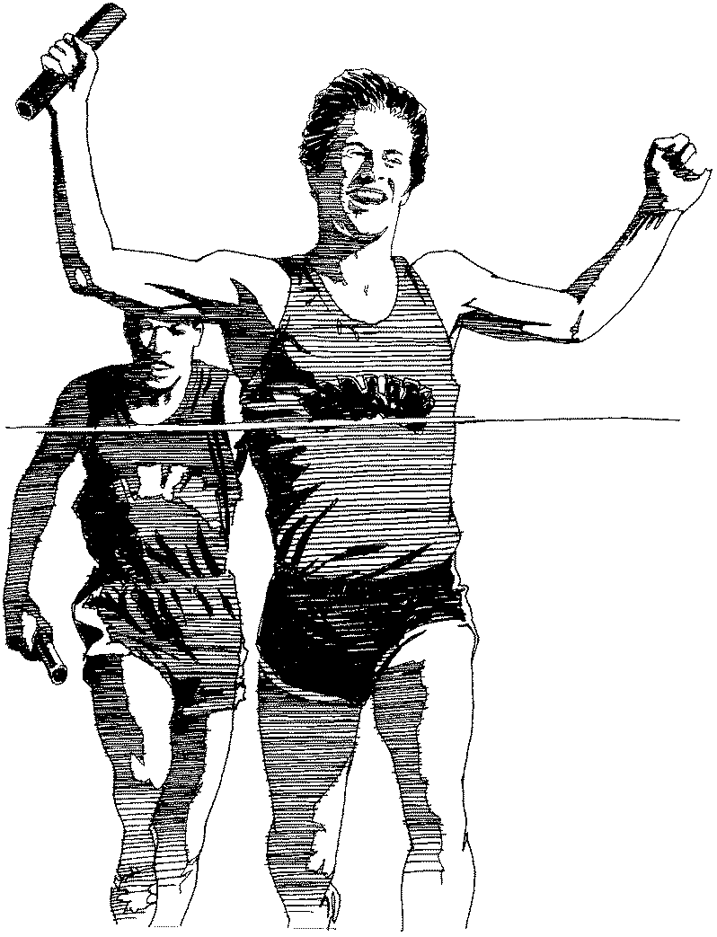

June 9-11
University of Montana

Missoula, Montana

Medals • Awards • Hats
T-shirts • Water Bottles • Prizes

Junior Olympic: 10-and-under to 18 years old
Open Division: 19+ years old
Master’s Division: 40+ years old

For more information, entry forms, guidebook, schedule:
Visit Association’s website @ www.mtusatf.org;
Local U.A.S. stores; Y.M.C.A. centers; or
David Hamilton, Meet Director
613 South Ave. W. – Missoula, MT 59801
E-mail: hamiltod@montana.com
“The Road to USATF Nationals in Indiana begins here!”

