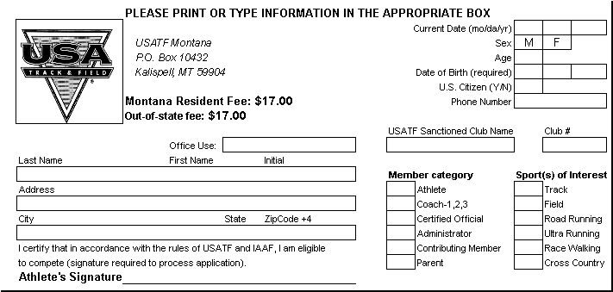

Registration Fee: $25.00
Late Registration Fee: $30.00

Missoula Youth Track Club 31-0125

X X
X

X

(If athlete is under age 18, parent or guardian must sign instead of athlete)

Registration Fee: $25.00
Late Registration Fee: $30.00

Missoula Youth Track Club 31-0125

X X
X

X

(If athlete is under age 18, parent or guardian must sign instead of athlete)

